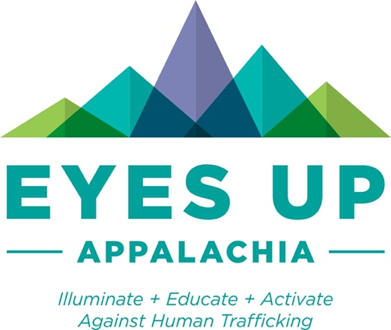

Eyes Up Appalachia Safe Person Social
Media Campaign

Please join us for our “Be Safe, Know Safe, Stay Safe” campaign!

Survivors of human trafficking, particularly those that were trafficked as children, often say that if they had a “safe person” or “trusted adult” in their life, they might have gotten out of it sooner. Community members often ask “What can I do?” This campaign puts those two thoughts together and asks that one simply be a safe person for someone that needs them. How do I do that you might ask? At https://www.eyesupappalachia.org/safeperson there are many resources to help you be that person simply by listening, believing and providing additional resources depending on the situation. Whether you are a parent, a coach, a teacher, a parishioner or any other community member that interacts with children, you can be that safe person!!

Our hope is that you will share the messages below on your social media. A suggested sequence of the posts follows with additional text suggestions. We suggest either posting in a series over 5 days during a week or pushing them all out as a blitz but no matter how you do it, we are grateful for your help!

For more information, contact Christi Scott Bartman at eyesupappalachia@yahoo.com .

Graphics

Hashtag recommendation:

#eyesupappalachia
#preventtrafficking

All graphics are available at https://bit.ly/SafePerson . An example and sample text follow:
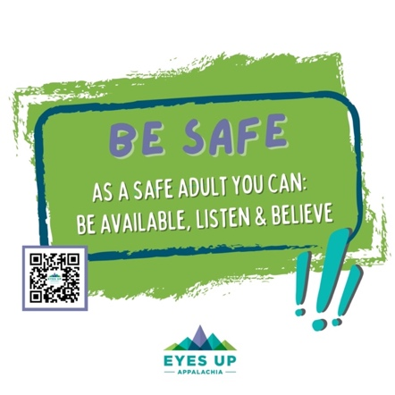
Sample Text: Human Trafficking survivors often say if they had a safe or trusted adult in their life, they may have gotten out of it sooner. You can be that SAFE PERSON! To learn more go to https://www.eyesupappalachia.org/safeperson .

#besafe

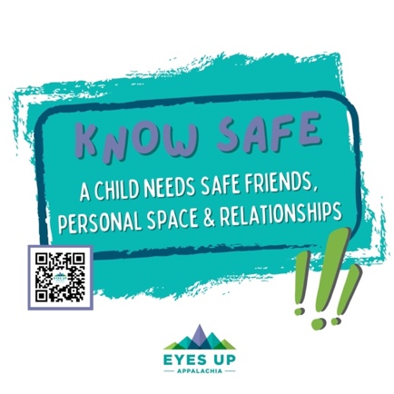

Sample Text: If children do not have safe friends, space or relationships they should reach out to a safe adult. Children should know two adults to whom they can go if they are not safe. For a planning worksheet for a child, see https://www.missingkids.org/content/dam/netsmartz/downloadable/tipsheets/who-is-a-trusted-adult.pdf .

#knowsafe

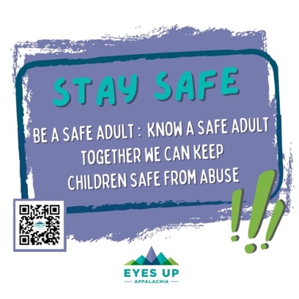

Sample Text: For a child it is not always easy to reach out to an adult. As an adult, it is not always easy to simply listen and make it easy for the child to talk to you. Check out these tips at https://www.missingkids.org/content/dam/netsmartz/downloadable/tipsheets/so-you-need-some-help.pdf .

#staysafe

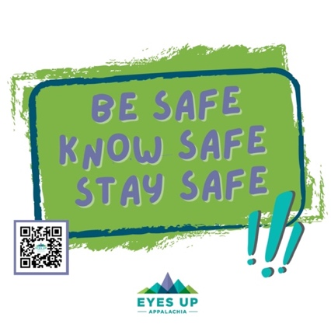

Sample Text: Whether you are a parent, a coach, a teacher, a parishioner or any other community member that interacts with children, you can be that safe person!! To learn more go to https://www.eyesupappalachia.org/safeperson .

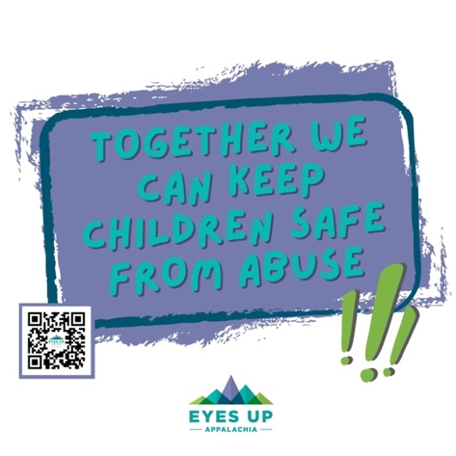
#besafeknowsafestaysafe

Sample Text: Sexual assault as a child is one of the key vulnerabilities that puts someone at an increased risk of being trafficked, particularly by a family member. To learn more go to https://www.eyesupappalachia.org/safeperson .
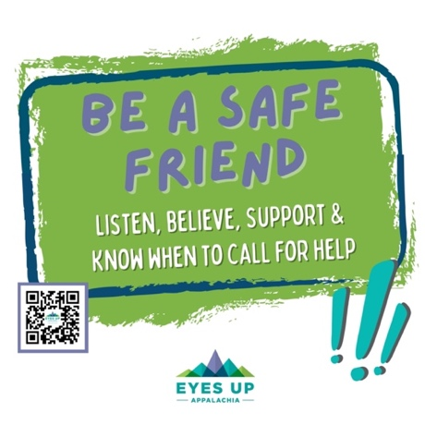

If your audience is more along the lines of college students, social groups or others where being a safe “friend” is more relevant, we have this for you:

Sample Text: Human Trafficking survivors often tell me that they did not have a safe or trusted person in their life. You can be that SAFE PERSON! To learn more go to https://www.eyesupappalachia.org/safeperson .

#beasafefriend

